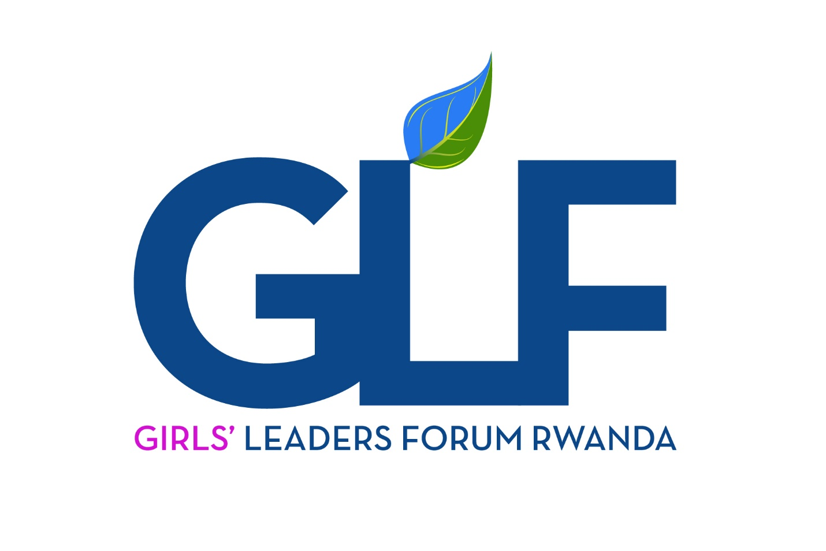

1. **BACKGROUND OF GIRLS’ LEADERS FORUM RWANDA**

Girls’ Leaders Forum Rwanda (GLF) is a Local Non- Government Organization that unites all Girls’ Leaders in the Universities and Higher Learning Institutions in Rwanda registered by RGB with No 130/RGB/NGO/LP/08/2017;

GLF Rwanda is dedicated to girls’ empowerment, founded in 2012 at National University of Rwanda, today, is operational in 25 Universities and Higher Learning Institutions and 5 Secondary Schools in Rwanda and currently have more than 300 active members.

GLF Rwanda comes to combine Girls’ efforts in order to speak one voice, to find solutions together and overcome different challenges that are related to Leadership, health and economic empowerment in their respective institutions and community at large, today 100% of the members are female youth.

**Our Vision:**

To become an innovative, empowered and self-reliant organization that is responsive to young women leadership challenges in order to build a strong society.

​

​**Our Mission**

To empower, inspire, motivate and support girls to exercise their rights and develop full potential so as to bring transformation through Governance, , good Health and economic development.

**Goals:**

* addressing the root causes of why girls get pregnant, drop out of school and also link it to leadership and being able to make their own choices
* Provide high quality non-formal education for girls
* Develop national and international partnerships
* Improve girls’ and women’s socio-economic lives

**Our Non-Formal Educational Method**

GLF uses non-formal education to support the empowerment of Girls and young people in diverse groups.

* Learning by doing
* Learning in small groups in HLIs and Secondary schools
* Connecting with others

1. **GLF STRATEGIC APPROACHES**
   1. **HOLISTIC**

The issues and problems affecting Girls and women in Rwanda are diverse in nature. There is therefore no one way to effectively address them. GLF views the problems affecting their constituents (Girls and women) in a holistic manner as a process of addressing them wholesomely and not as dealing with just some particular aspects. GLF will integrate different approaches to jointly address the issues of improved health and Governance service delivery and poverty reduction by preventing the continued spread and mitigating the effects of unwanted pregnancies, drug abuse, advocating for Girls’ rights.

* 1. **CAPACITY BUILDING AND EMPOWERMENT**

GLF considers Girls and women empowerment as a process, strategy of increasing the political, social or economic strength of individuals, member organizations, communities and beneficiaries to have: the right/ power to decision-making; access to information and resources; have a range of options to make choices; develop assertiveness in collective decision making; have ability to learn new skills; ability to democratically change others’ perceptions and ability to influence the direction of social change. Capacity building will include:  
- Coordinating and building capacities of GLF Members and Gender Clubs to increase the efficiency  
- Human resource development as a process of educating, training and equipping individuals with skills and access to information, knowledge and experiences to increase performance;  
- Organizational development as a strategy to streamline management structures, strengthen internal processes and procedures, develop/ improve policies and programs and develop a network of donors.  
- Building partnerships as a strategy where GLF members willingly come together formally or informally to achieve a common purpose.   
- Extending small grants to help GLF branches in Schools to increase implementation, scaling up best practices and technical capacity.

* 1. **RIGHTS BASED**

A rights-based approach to development promotes justice, equality and freedom and tackles the power relation issues that lie at the root of poverty and exploitation in order to address structural causes of gender inequalities. GLF will strategically use Rights-based programming to hold people and institutions holding power accountable to fulfill their responsibilities toward those with less power. It will mobilize and support right holders to demand their rights and to be involved in political, economic and social decisions in society. GLF will put pressure on power holders (decision makers) at local and national level to develop and/ or change policies, laws, programs and budget allocations. GLF will use the media to raise awareness, monitor and report abuses of power and human rights violations; audit the quality of Government services and promote human rights education.

* 1. **VOLUNTARY COMMUNITY PARTICIPATION**

GLF considers community participation as a strategy of involving beneficiaries, network members and other stakeholders voluntarily in the process of solving their own problems. Volunteering is a way in which individuals freely give out time and energy to render free services that bring measurable benefits to the volunteer, individual beneficiaries, groups and organizations, communities they work in and is not motivated primarily for financial gain, a wage or salary. GLF has a critical mass of Graduates, trained community volunteers (peer educators, Mentors,) who play a key role as first line workers in: carrying out Adolescent Sexual Reproductive Health Rights, Leadership and Entrepreneurship; campaign for anti-teenage pregnancies and promotion of values. GLF will continue to recruit, train and conduct refresher courses to keep the volunteers knowledgeable of current Governance, Health, SGBV, human rights issues. GLF will also partner with organizations that are involved in volunteer and intern placement to tap their expertise and experience so as to reinforce the existing mass of volunteers and facilitating their work in kind.

* 1. **GENDER MAINSTREAMING**

Mainstreaming gender is not just about “including” women and girls, or mere addition of women’s rights elements but contributing to Transformation. GLF will under-take to: strengthen the capacity of staff and partners in mainstreaming gender; develop specific gender interventions or programs that focus on: SGBV against Girls and women; Gender equality and Girls and Women’s participation in politics , GLF will promote building internal capacity for gender monitoring and evaluation while strengthening the alignment of resources with the gender commitments e.g. Re- establishment of Gender Clubs in Higher Learning Institutions and creating networks of exchange and learning that build on experiences both within and outside the organization.

**2.6 ADVOCACY AND NETWORKING**

GLF considers advocacy as aimed at changing the status of policies, strategies or programs. Advocacy is implied as: undertaking research to clarify issues on Unwanted pregnancies, Girls and women rights to property, inheritance, land and Sexual and gender based violence; providing evidence based information and education to all concerned parties for achievement of equality for rights, access for all to Health services, liberation from poverty and total enjoyment of peace and freedoms; building partnerships, alliances, networks and coalitions on the issues being advocated for so as to build a collective voice; dialoguing and negotiating with individuals and organizations with contrary views and positions

GLF will focus attention on the power relationships between people, households and authority structures where it will hold duty bearers responsible to their obligations by holding regular platform meetings with; local administrations, parliamentary sessional and/ or caucus committees, ministers, law enforcers, judiciary, on issues of Health, low status of Girls and women, SGBV, economic empowerment.

**3.CURRENT & FUTURE PROJECTs**

* 1. **Re-establishment of Gender Clubs in Schools**

GLF in partnership with the Ministry of Gender and Family Promotion will implement gender equality project through Re- establishment of Gender Clubs in Higher Learning Institutions to contribute to the promotion of Gender equality and fight against gender-based violence. The project’s objective is to see Rwandan youth especially Girls and boys in 10 Universities and Higher Learning Institutions actively engaged in gender equality promotion and fight against gender-based violence in their institutions and communities for improved socio-economic welfare.

**3.2 Girls in Leadership**

Urashoboye is a project of the Girls’ Leaders Forum in collaboration with Pro-Femme Twese Hamwe for strengthening the capacity building of girls in leadership through the program called “Women can do it” in 4 HLIs ( UR-Huye, CAVM Busogo, Nyarugenge campuses and ICK Kabgayi.

Started in September 2014, women can do it aims to expand and improve delivery of new skills and tools for Girls and women’s effective leadership; provide a space for sharing experiences and for networking to mobilize them for change; and offer state-of-the-art leadership training for the empowerment of young Rwandan women. The project also aims to benefit established women leaders who need to strengthen their leadership skills and knowledge for better outcomes in girls’ education, girls and women’s economic empowerment and groups of young women who learn new skills to help them exercise leadership potential to bring the transformation in our society.

So far, 120 girls’ leaders benefited from this program, some of them are in local Government, civil society organizations and private sector.

**3.3 Fight against Unwanted/teenage Pregnancies**

Through MENYA N’IBI Project, GLF will work to Prevent and Respond to GBV especially Teenage /Unwanted Pregnancies in 5 HLIs and to promote children’s rights as well as following up the GBV Perpetrators ( UR- Nyagatare Campus, INIK Kibungo, UR- CBE,IPRC- Kigali ,UR-CASS,Huye Campus and 2 Secondary Schools( ACEJ Karama, G.S Saint Joseph Kabgayi).

**3.4 Mentorship**

500 girls between 12 to 25 years of age in Higher Learning Institutions, Secondary schools where GLF is operational to be mentored in order to increase the number of women and girls in leadership position at the corporate and political levels. It is a program that will provide support mechanisms to women and girls to enable them develop adequate skills as well as inspire them to take up leadership positions.

**3.5 Women/Girl economic empowerment**

Environment protection byplanting oil trees in Rwanda for climate change mitigation for ‘ejoheza’ savings in Musanze, Rwamagana and Huye districts for addressing unemployment and poverty issue among young women.

**4. KEY ACHIEVEMENTS**

* Today, GLF have been Launched in 15 Universities and Higher Learning Institution including public and private and 5 secondary schools; 10 HLIs, GLF is operational but not yet launched officially;
* **on Seruka/Mentorship program for graduates,** in collaboration with US-Embassy, 20 GLF Graduates members provided mentorship skills in leadership; through the Women Leaders Fellowship
* **On** **Umwari ubereye u Rwanda program** we have a partnership between GLF and Pro-Femmes Twese Hamwe especially in strengthening the capacity building of girls in leadership through the program called “Women can do it” in 4 HLIs which are UR-Huye, Busogo, Nyarugenge campuses and ICK Kabgayi, 120 girls benefited from this program between 2015-2018;
* **On Urashoboye**: we conducted leadership training every year so far, girls become more confident to compete and occupy different positions within Universities students’ unions like Guild presidents, vice presidents, Finance, and others as well as making an impact for the well-being of their fellow students
* On **Menya nibi program** /**Induction program for new comers ,**we work with Universities and HLIs especially in preparation and conducting induction week every year especially for girls in order to equip them with reproductive health skills and fight against unwanted pregnancies and STIDs in 25 Universities for example In collaboration with MIGEPROF, GLF conducted Anti-Teenage pregnancy campaign in 2 years (2016-2018): TTC MATIMBA, GS MUSANZE I, FAWE GIRLS SCHOOL, GS APEBU, GS RUYENZI, LYCEE DE RUHANGO, TTC MURAMBA,ACEJ KARAMA and GS GACUBA II.

**5. PARTNERS**

* Ministry of Gender and Family Promotion(MIGEPROF)
* Rwanda Governance Board (RGB)
* National Youth Council (NYC)
* Pro-Femme Twese hamwe
* USA Embassy

**6.STRUCTURE**

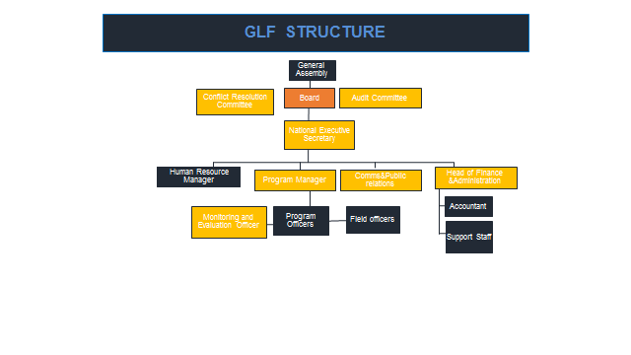

**CONTACT**

Gasabo District, Kimironko Sector ,rwahama road,Martin Plaza,2nd floor,Kigali-Rwanda

[Tel:+250785758549/0788310415/0783231321](tel:+250785758549/0788310415/0783231321)

Email:glfrwanda@gmail.com/rnkundimfura@yahoo.com/umukunzivictoire@gmail.com